Replication rule for replicate data from bucket to bucket

1. First sign in aws ac and go through s3 service
2. Select the bucket which is use for replication data from bucket to bucket.

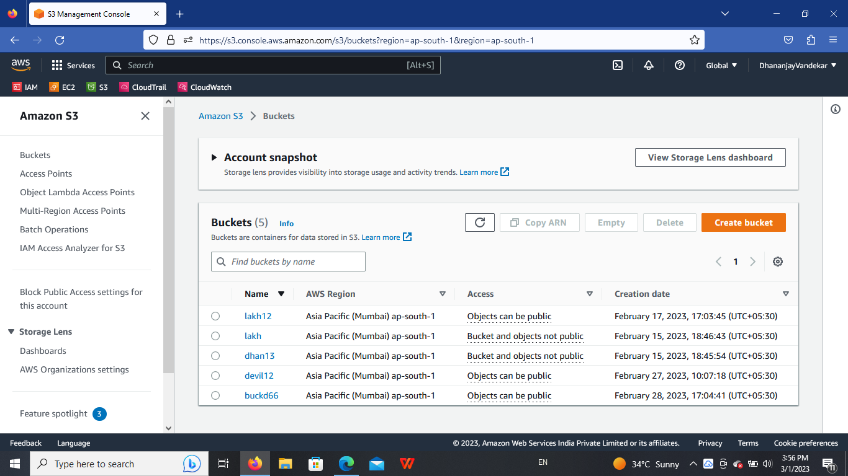

1. Go inside the lakh12 and go to the management and click on create replication rule.

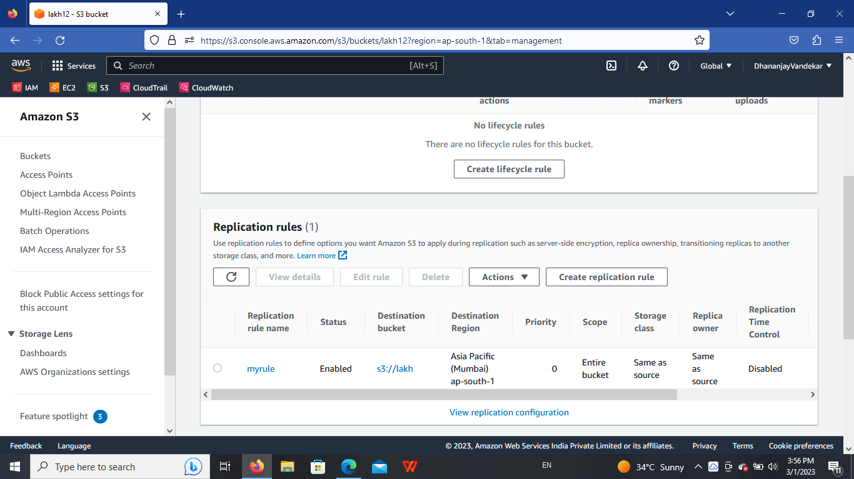

1. Add name of rule and add extension and browse the bucket which we want to add for replication rule.

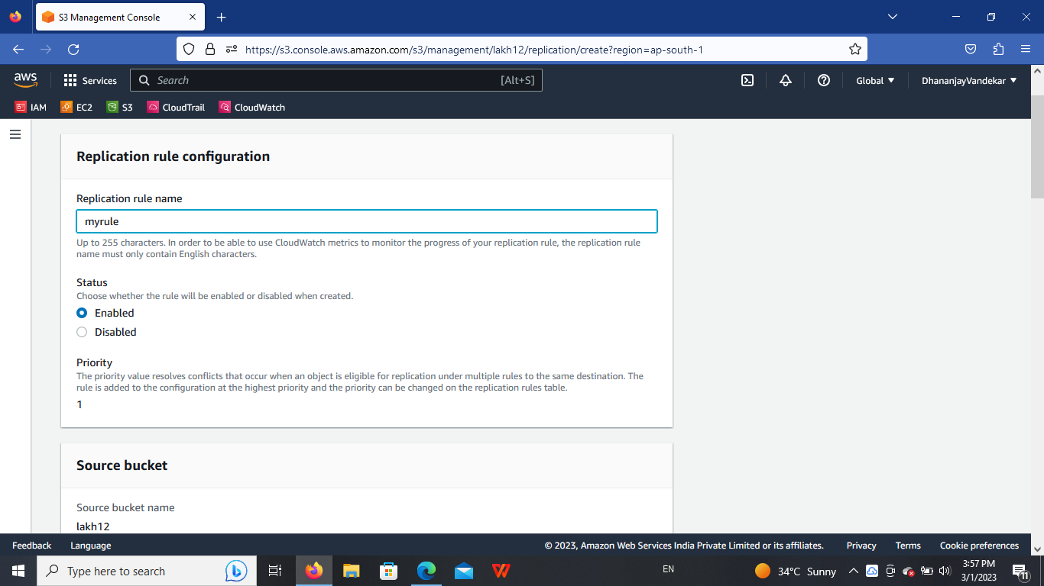

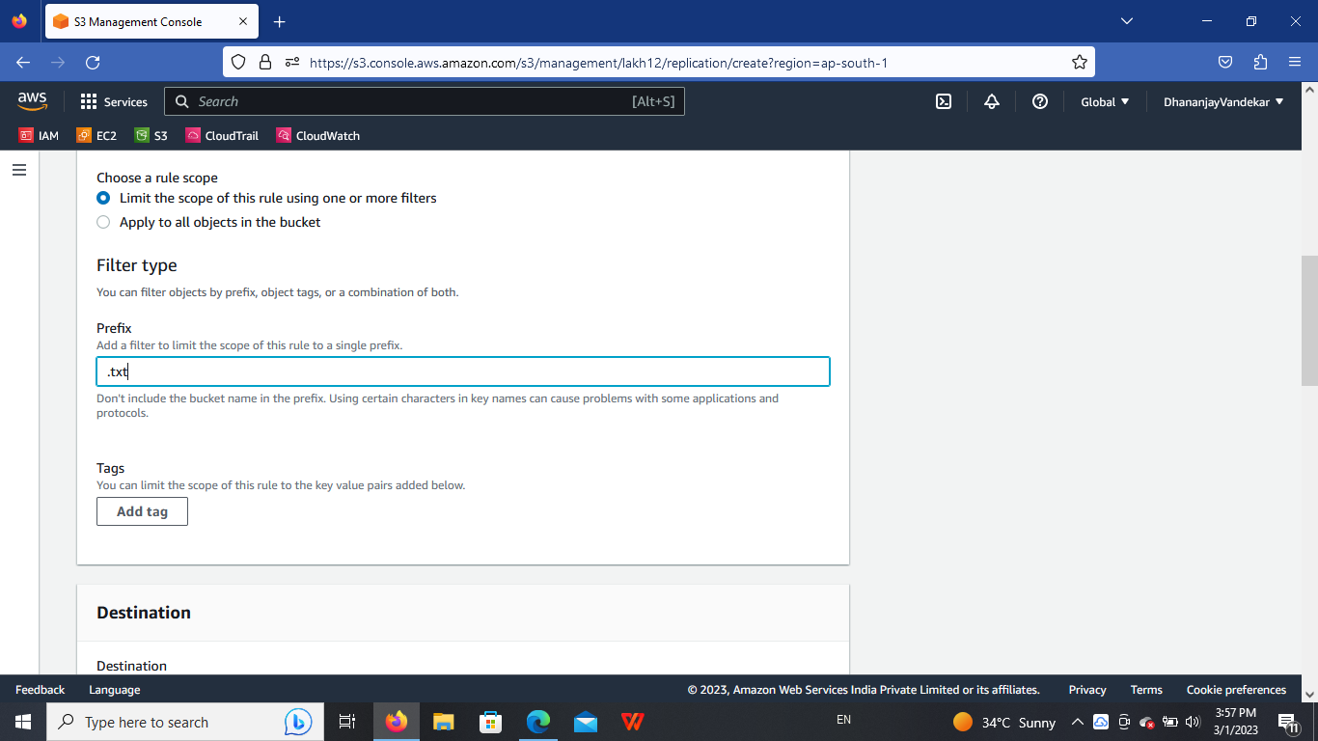

Browsing bucket

We use lakh bucket foe browsing with lakh12 bucket replication of data.

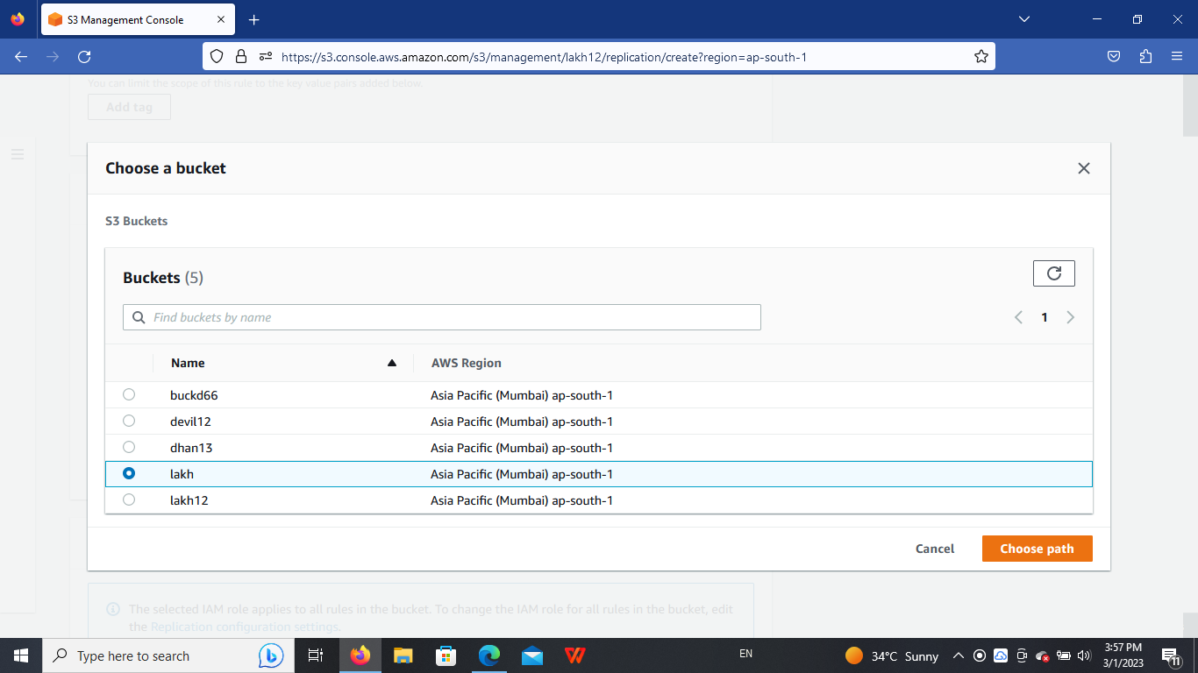

Then save the replication rule.

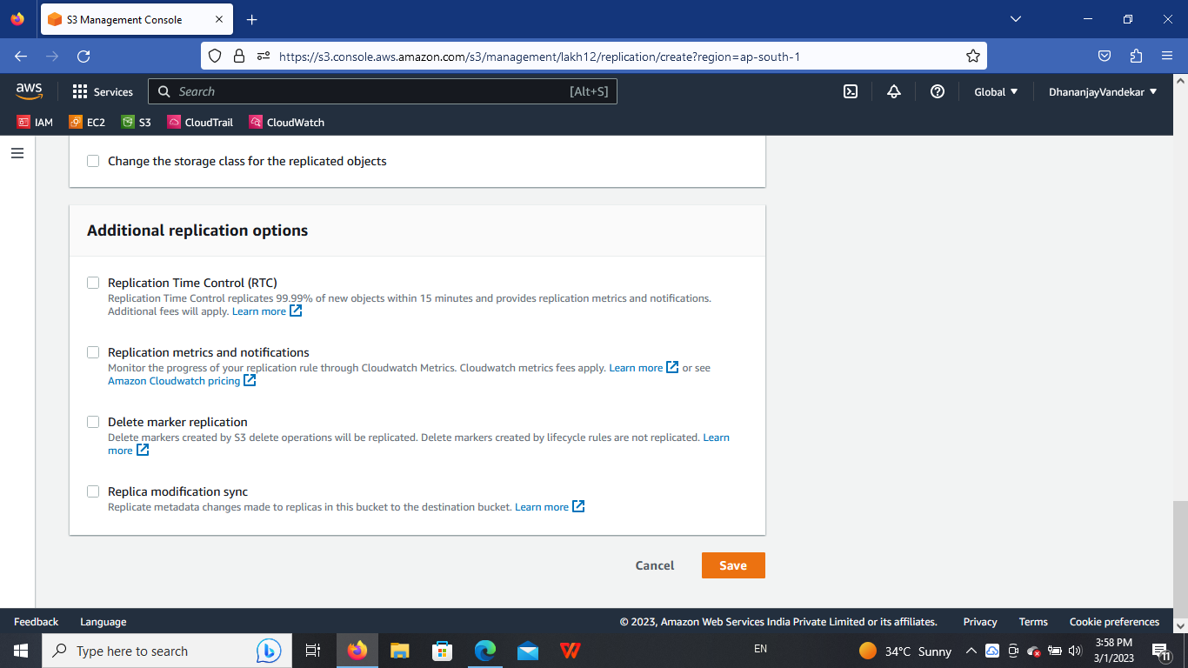

Then we have seen this rule in under management of the given bucket.

Our rule name is my rule.

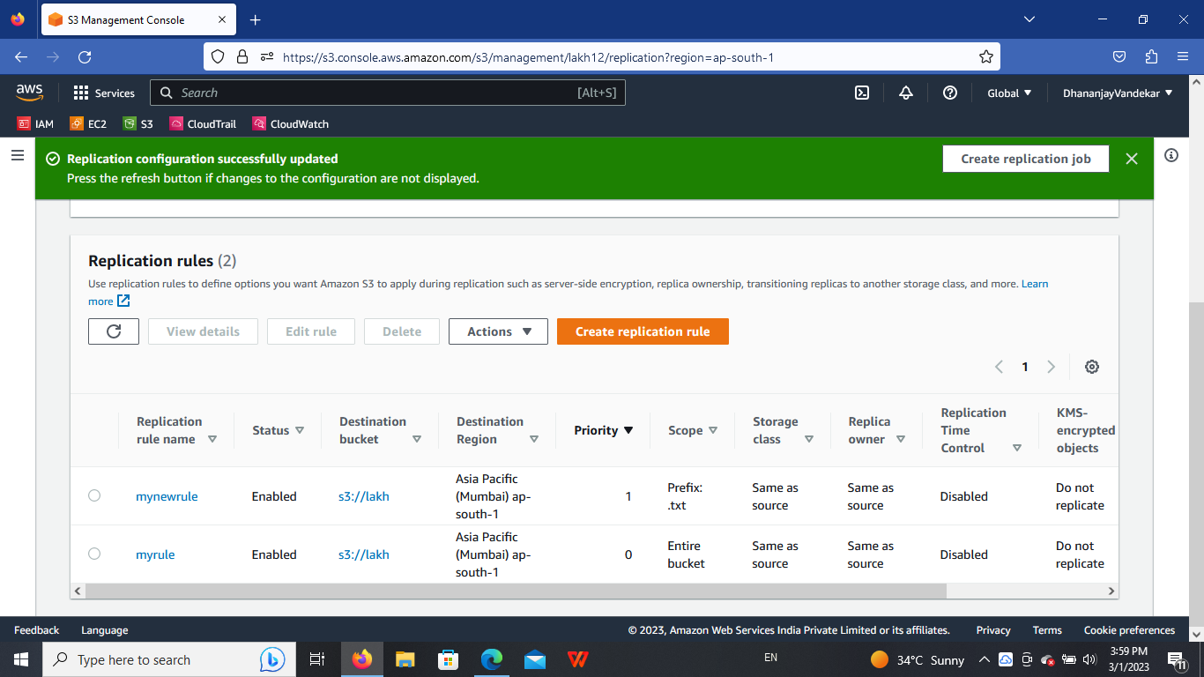

Then go inside our choosen bucket and upload one doc in it same time of doc uploaded in the bucket we have chosen for replication rule.

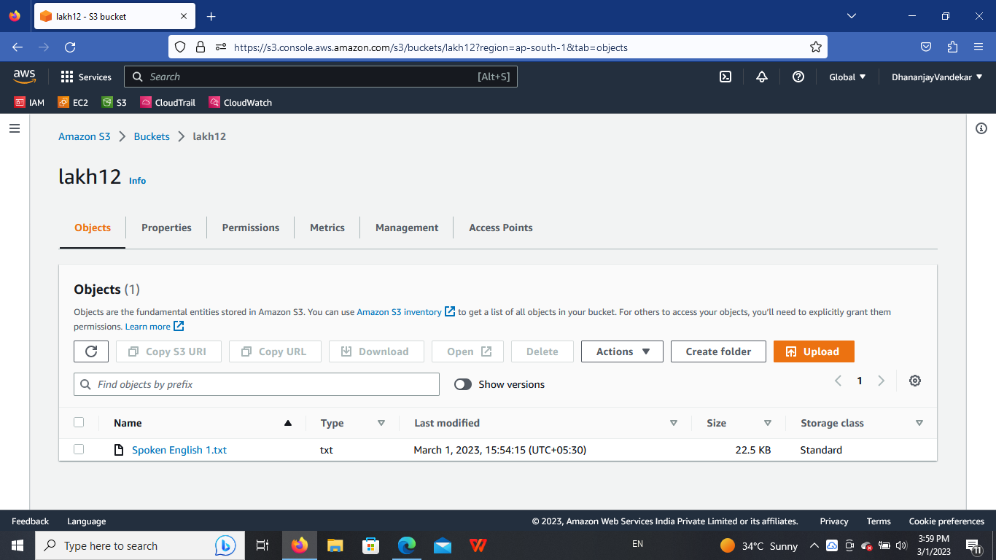

Then go inside another bucket that is lakh.

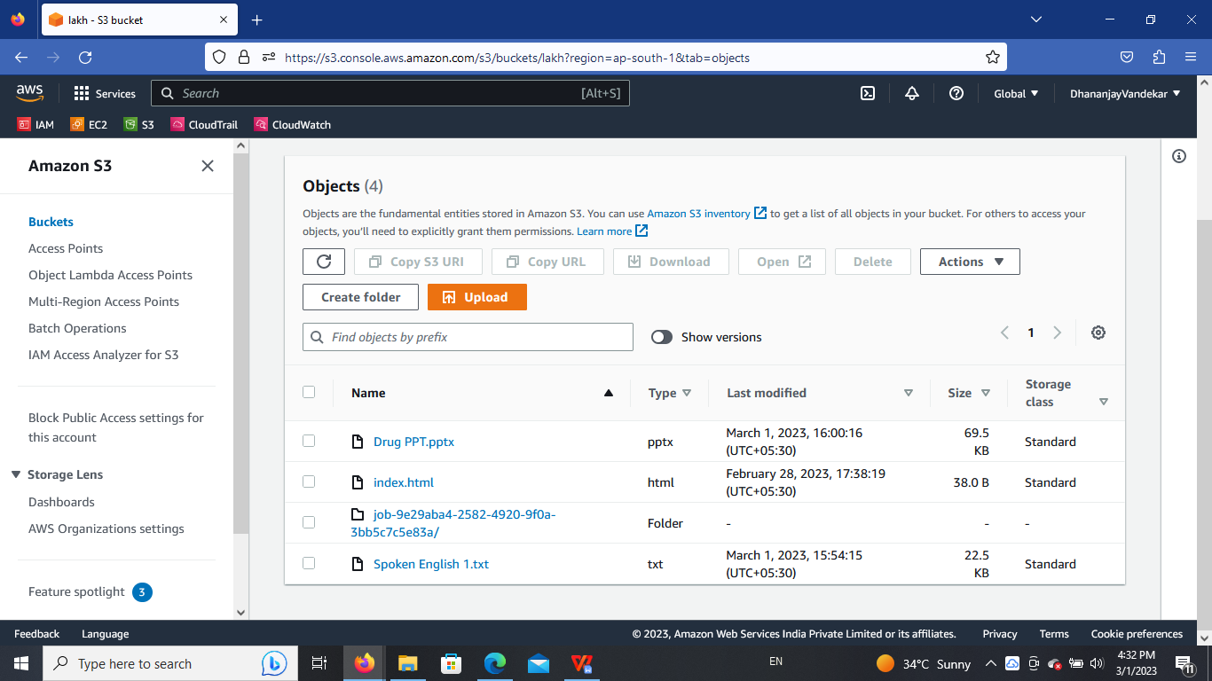

This is our rule for replication of data from one bucket to another bucket.